

**PALOMPON INSTITUTE OF TECHNOLOGY**

**COLLEGE OF TECHNOLOGY AND ENGINEERING**

**INFORMATION TECHNOLOGY DEPARTMENT**

**PROJECT DOCUMENTATION OF**

**STUDENT ALLOWANCE EXPENSES TRACKER**

A requirement for the subject IT111-Web Programming

**Submitted to:**

**Prof. Rogelio Urboda Jr.**

Subject Instructor

**Submitted by:**

**Larido, Michael John**

**Bianzon, Sean Benedict**

**Terrado, Jaylo**

**Gonzaga, Jessa**

**Dangel, Jenevieve**

**Alcuetas, Nicole**

**2024**

**Project Plan**

**Objectives:**

Develop a system to track and manage student allowance expenses efficiently, with features for budgeting, spending tracking, and generating reports.

|  |  |  |  |  |  |  |
| --- | --- | --- | --- | --- | --- | --- |
| Task Name | Duration | Start | Finish | Resource  Name | %Complete | Description |
| Create Entity Relationship Diagram | 1 day | Wed 11/20/24 | Wed 11/20/24 | Larido, Bianzon | 100% | Initial ER diagram creation to represent system entities. |
| Review and Finalize ER Diagram | 1 day | Thu 11/21/24 | Thu 11/21/24 | Bianzon, Alcuetas, Terrado, Larido, Dangel, Gonzaga | 100% | Group review and final adjustments of the ER diagram. |
| Brainstorming of Features for System | 1 day | Thu 11/28/24 | Thu 11/28/24 | Bianzon, Alcuetas, Terrado, Larido, Dangel, Gonzaga | 100% | Brainstorming session to identify essential features |
| Review and Finalize of Features for System | 1 day | Thu 11/28/24 | Thu 11/28/24 | Bianzon, Alcuetas, Terrado, Larido, Dangel, Gonzaga | 100% | Finalizing system features based on brainstorming. |
| Assigning the Roles of Members | 1 day | Fri 11/29/24 | Fri 11/29/24 | Larido | 100% | Define roles and responsibilities of each team member. |
| Create Mock-UP Design for UI | 3 days | Fri 11/29/24 | Tue 12/3/24 | Gonzaga, Dangel | 100% | Create UI mockups that visualize the system interface. |
| Adjusting the ER Diagram | 1 day | Tue 12/3/  24 | Tue 12/3/ 24 | Bianzon, Larido | 100% | Add new "Account" entity to the ER diagram. |
| Develop and Integrate Design | 4 days | Tue 12/3/  24 | Fri 12/6/  24 | Bianzon, Larido | 100% | Integrate and develop the system's front-end and back-end design |
| Create Back-end for System | 4 days | Fri 12/6/ 24 | Wed 12/11/24 | Bianzon, Larido | 100% | Development of the back-end functionality and database |
| Draft Testing of System Fuctionalities | 3 days | Wed 12/11/24 | Fri 12/13/24 | Bianzon, Alcuetas, Terrado, Larido, Dangel, Gonzaga | 100% | Conduct initial testing to validate system functionalities. |
| Finalization for System and Documentation | 2 days | Fri 12/13/24 | Mon 12/16/24 | Bianzon, Terrado, Alcuetas | 100% | Finalize the system and prepare documentation for deployment. |

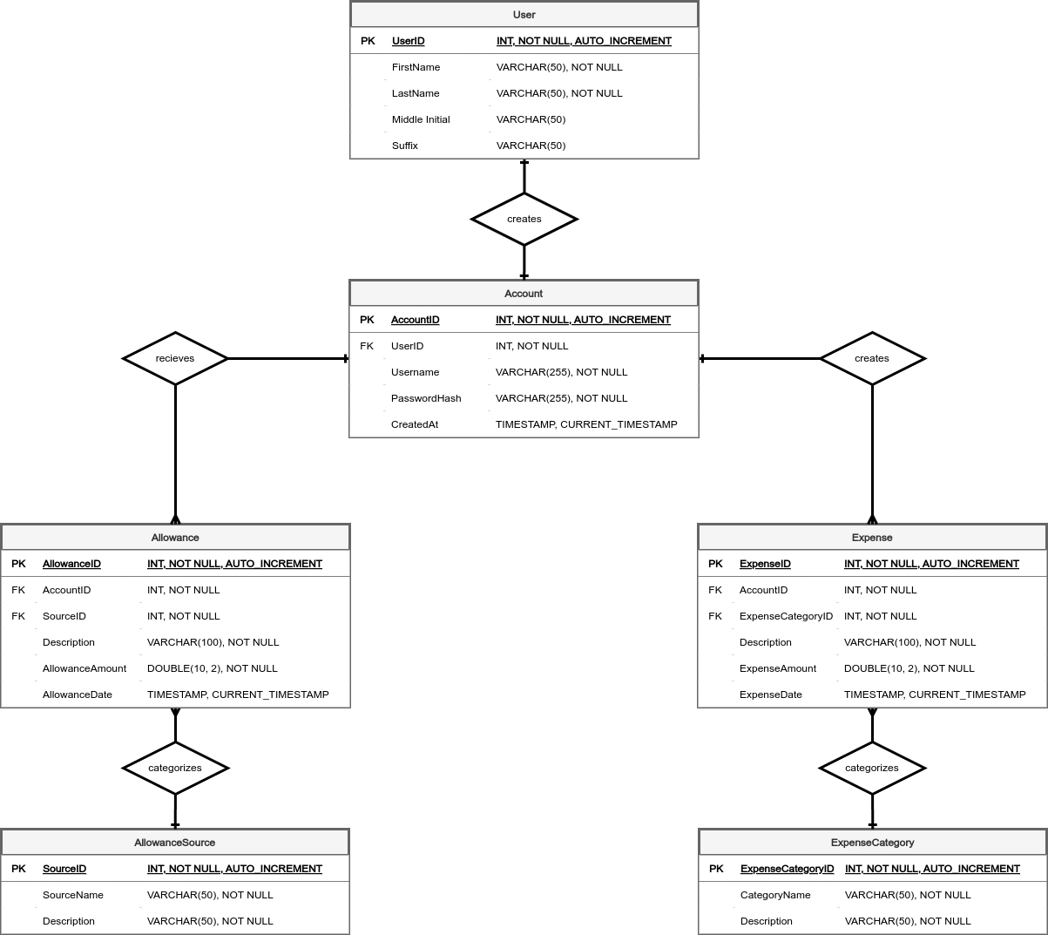**Entity Relationship Diagram**

**CRUD Pages Screenshots**

